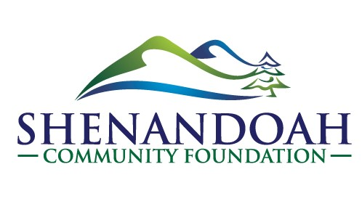
Position Title – Administrative Assistant
Employment Classification – Regular, part-time (16 hours/week)
Application Deadline – April 15, 2021

The individual in this position will assist with communications, grant and scholarship programs, and donor management. The Administrative Assistant will work with staff, the Board and its committees, volunteers, donors and fund sponsors, charitable agencies, and the public.

Duties of the Position
The Administrative Assistant will assist with a variety of communications, development, and administrative needs of the Community Foundation.
- Assist with various functions, including communication (email, phone, text, face-to-face, and written) with donors, fund sponsors, charitable agencies, grant and scholarship committees, board members, applicants and grantees, and the public;
- As assigned, assist with the coordination and preparation of materials for both committee and board meetings, and disseminate information prior to meetings;
- Assist with fundraising and special events;
- Aid in the collection of data for various projects and publications;
- Inventory and maintain supplies according to office needs and prepare and submit supply orders, payment invoices, and reports;
- Maintain office equipment and secure servicing, as needed;
- Perform other duties as assigned.

Job Qualifications and Requirements
Minimum: Associate’s degree or equivalent work experience
- Excellent verbal, written, and interpersonal communication skills;
- High level of organizational skills;
- Proficient knowledge of Microsoft Office products, including Word, Excel, and PowerPoint;

- Ability to multi-task and prioritize projects to meet deadlines and emerging needs;
- Ability to effectively work independently and as a team member;
- Professional demeanor and appearance;
- Interest in improving the quality of life in Shenandoah County;
- Positive, can-do attitude and ability to focus work on meeting or exceeding goals;
- Knowledge and experience about community organizations is desirable.

Salary
- Compensation commensurate with salary standards and work experience.

Application Process
Email cover letter and resume to info.scfva@gmail.com or mail to Shenandoah Community Foundation, PO Box 31, Woodstock, VA 22640, to be received no later than April 15, 2021.

Shenandoah Community Foundation is an Equal Opportunity Employer

