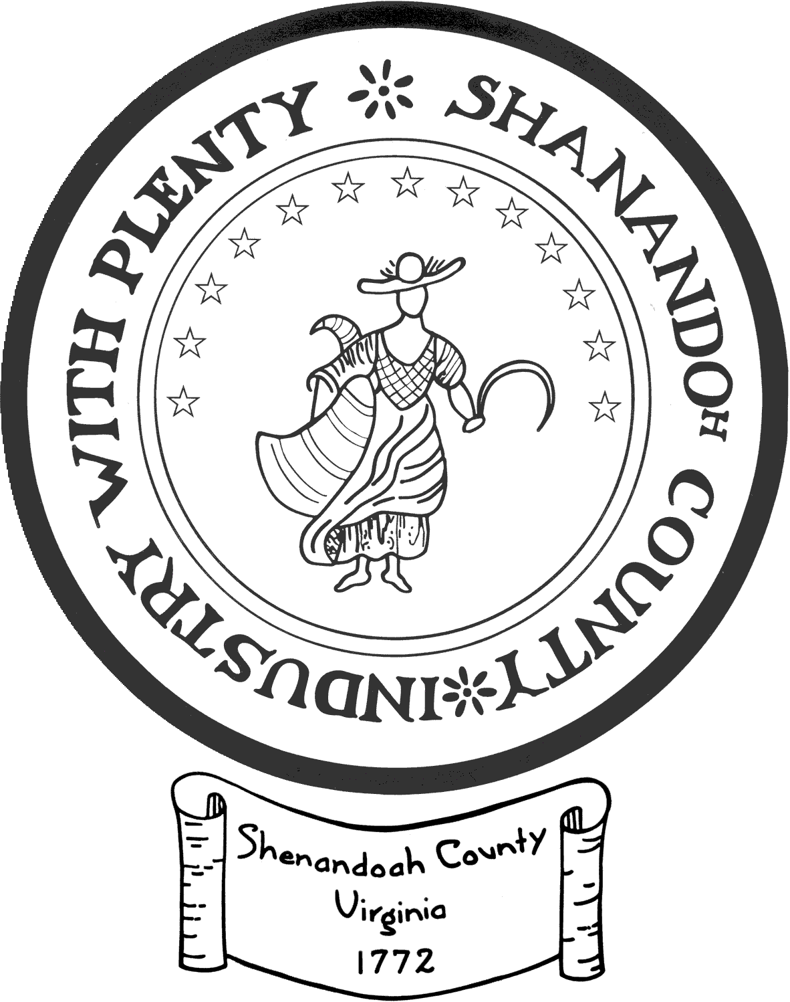
Shenandoah County Support of Local Arts
Grant Application

Description:
Shenandoah County will award up to $9,000, subject to funds available, to local arts organizations impacting Shenandoah County.

Eligible Applicants:
Grants to independent arts organizations for arts activities within Shenandoah County. Must be a 501©3, not-for-profit organization. No county government unit may apply. For example, Shenandoah County Parks and Recreation may not apply for funds to support a painting or musical program or event.

Deadline:
February 14, 2022 by 5:00 PM, for funds awarded in Fiscal Year 23 (July 1, 2022-June 30, 2023).
NOTE: Funds will not be distributed until Fall 2022.

Application/Review/Payment Procedures:
1. Local arts organizations to submit completed application by February 14, 2022 deadline.
2. Local Arts Committee to review applications.
3. Local Arts Committee will take final action and notify recipient(s) in July 2022.
4. After confirmation of the grant award, recipient arts organizations will submit a letter to Shenandoah County Tourism requesting the awarded funds.
5. Checks will be distributed to recipient organizations in Fall 2022.

-------------------------------------------------

1. Applicant Name: 2. Federal Tax ID #
3. Are you a 501©3 non-profit? Yes No
4. Mailing Address:
5. Physical Address (if different):
6. Website:
7. Contact Person: 8. Contact Title:
9. Contact Email: 10. Telephone:
11. Total Project or Organization Cost: 12. Amount Requested:
13. Provide a brief description of your organization. (History, current programming, leadership, etc)
14. Tell us about the purpose and scope of the project that you hope to fund with this grant money.
15. How would you use the funds if awarded? (you may attach an itemized budget of how the funds would be used if awarded)
16. How does your organization or program provide services that would otherwise not be met should your organization not exist or your project does not receive grant funding?
17. How would you adapt your program or adjust spending within the organization if you did not receive full funding?
18. What is your organization’s reach or the proposed reach of your project? (check all that apply)
Local Shenandoah County Residents
Regional Shenandoah Valley
Statewide
Out of State
Other (please specify)
19. Please provide any data you may have to support your answer to question 18:

21. Populations Benefited:
Select any categories that, by your best estimate, will make up 25% or more of the population that directly benefits from the award during the period of support. These responses should refer to populations reached directly, rather than through broadcasts or online programming.

Populations Benefited By Race: Populations Benefited By Age:
American Indian/Alaskan Native Children/Youth (0-18 years)
Asian Young Adults (19-24 years)
Black/African American Adults (25-64 years)
Hispanic/Latino Older Adults (65+ years)
Native Hawaiian/Other Pacific Islander No single age group made up
White more than 25% of the
No single race/ethnic group listed above made population directly benefited
up more than 25% of the population directly benefited

Populations Benefited by Distinct Groups: Arts Education:
Individuals with Disabilities Choose the one item which best describes the
Individuals in Institutions (include funded activities.
people living in hospitals, hospices, nursing 50% or more of the funded activities are
homes, assisted care facilities, correctional arts education directed to K-12 students,
facilities, and homeless shelters) higher education students, pre-K
Individuals below the Poverty Line children, and/or adult learners (including
Individuals with Limited English Proficiency teachers and artists).
Military Veterans/Active Duty Personnel Less than 50% of the funded activities
Youth at Risk are arts education directed to K-12
No single distinct group made up more than students, higher education students,
25% of the population directly benefited pre-K children, and/or adult learners.
None of the funded activities involve arts education.

